

**Capstone Project Report**

**Report 1 – Project Introduction**

– Ho Chi Minh City, January 2021 –

**Table of Contents**

I. Project Report 3

1. Status Report 3

2. Team Involvements 3

3. Issues/Suggestions 3

II. Project Introduction 4

1. Overview 4

1.1 Project Information 4

1.2 Project Team 4

2. Product Background 4

3. Existing Systems 5

3.1 CRMViet 5

3.2 GetFly 5

3.3 EasyEdu 6

4. Business Opportunity 7

5. Software Product Vision 8

6. Project Scope & Limitations 8

6.1 Major Features 8

6.2 Limitations & Exclusions 8

# I. Project Report

## 1. Status Report

|  |  |  |  |
| --- | --- | --- | --- |
| **#** | **Work Item** | **Status** | **Notes (Work Item in Details)** |
| 1 |  | Pending |  |
| 2 |  | In Progress |  |
| 3 |  | Completed |  |

## 2. Team Involvements

|  |  |  |  |
| --- | --- | --- | --- |
| **#** | **Task** | **Member** | **Notes (Task Details, etc.)** |
| 1 |  | HaPTN |  |
| 2 |  | NguyenLG |  |
| 3 |  | GiaNH |  |
| 4 |  | ~~PhuVT~~ | Dropped since January 28th, 2021 |

## 3. Issues/Suggestions

|  |  |  |  |
| --- | --- | --- | --- |
| **#** | **Issue** | **Status** | **Notes (Solution, Suggestion, etc.)** |
| 1 |  | Pending |  |
| 2 |  | In Progress |  |
| 3 |  | Completed |  |

# II. Project Introduction

## 1. Overview

### 1.1 Project Information

* Project name: Sales Management System for Major Education
* Project code: SMSME
* Group name: GSP21SE12
* Software type: Web Application

### 1.2 Project Team

#### a. Supervisor

|  |  |  |  |
| --- | --- | --- | --- |
| **Full Name** | **Email** | **Phone Number** | **Title** |
| Lai Duc Hung | HungLD5@fe.edu.vn | 0976.710.580 | Instructor |

#### b. Team Members

|  |  |  |  |
| --- | --- | --- | --- |
| **Full Name** | **Email** | **Mobile** | **Role** |
| Pham Thi Ngoc Ha | HaPTNSE130460@fpt.edu.vn | 0946.753.053 | Leader |
| Le Gia Nguyen | NguyenLGSE63042@fpt.edu.vn | 0984.272.299 | Member |
| Nguyen Hoang Gia | GiaNHSE63203@fpt.edu.vn | 0799.651.670 | Member |
| ~~Vu Thien Phu (dropped)~~ | ~~PhuVTSE63268@fpt.edu.vn~~ | ~~0946.056.921~~ | ~~Member~~ |

## 2. Product Background

Major Education is an educational organization that collaborates with primary schools, secondary schools or high schools in Ho Chi Minh City, in the fields of English, STEM or Abacus Master. All schools in Ho Chi Minh City are considered as Major Education’s customers/partners. Every school year (from May to September), salesmen from Major Education go to the target schools to introduce and sales their programs.

Currently, the Sales Department of Major Education processes all their works manually, from reports collecting, work-plan planning, salesmen managing and target schools managing, based on free software such as Microsoft Excel, Google Sheet and shared files via Google Drive cloud.

Therefore, they expect a software that can help them, for both salesmen and sales managers, to automate the existing manual workflow. Simultaneously, through this application, sales managers will be able to see the overall picture of the company's business process, to know how many schools are cooperating as well as the school’s state.

## 3. Existing Systems

Nowadays, there are a variety of applications that provide CRM (Customer Relationship Management) solutions for businesses. Major Education suggests our team refer to those softwares to visualize the concept and main features of the future product.

### 3.1 CRMViet

CRMViet is a system that provides comprehensive solutions related to CRM for small and medium-sized enterprises (SME) in Vietnam.

*Link:*

* Web application: <https://crmviet.vn/>.
* Mobile application:
  + Android: <https://play.google.com/store/apps/details?id=vn.altalab.app.crmvietpack>.
  + iOS: <https://apps.apple.com/us/app/crmviet/id1197961185>.

*System analysis:*

1. Roles:

* Administrator
* Manager
* Staff
* … (customized roles depends on each company)

1. Platforms:

* Web app
* Mobile app

1. Main features:

* Manage customers
* Support sales and marketing automation
* Manage workflow, tasks, job reminders,…
* Integrated multi-channel
* …

1. Pros:

* A complete and powerful application
* Fulfill all needs of the Major’s Sales Department

1. Cons:

* Many redundant features
* Price is expensive

### 3.2 GetFly

GetFly is a system that provides comprehensive solutions related to CRM for small and medium-sized enterprises (SME) in Vietnam.

*Link:*

* Web application: <https://getfly.vn/>.
* Mobile application:
  + Android: <https://play.google.com/store/apps/details?id=com.getflyvn.crm>.
  + iOS: <https://apps.apple.com/us/app/getflyvn/id1490060413>.

*System analysis:*

1. Roles:

* Administrator
* Manager
* Staff
* … (customized roles depends on each company)

1. Platforms:

* Web app
* Mobile app

1. Main features:

* Manage customers
* Support marketing automation (via SMS, email, or social network)
* Manage departments, sales team,…
* Manage workflow, tasks, KPIs,…
* Integrate modules extension
* …

1. Pros:

* A complete and powerful application
* User-friendly UI
* Fulfill all needs of the Major’s Sales Department

1. Cons:

* Overpowered, many redundant features
* Require monthly payment

### 3.3 EasyEdu

EasyEdu is a system to manage all activities of many departments in an educational organization, especially for language centers. EasyEdu provides solutions for managing finances, expenses, marketing, human resources, class attendance reports, CRM,…

*Link:*

* Web application: <https://easyedu.vn/>.
* Mobile application:
  + Android:

Teacher: <https://play.google.com/store/apps/details?id=com.easyedu.manager&hl=vi>.

Parent/Student: <https://play.google.com/store/apps/details?id=com.easyedu.customer&hl=vi> .

* + iOS:

Teacher: <https://apps.apple.com/vn/app/easy-manager/id1495280190?l=vi>.

Parent/Student: <https://apps.apple.com/vn/app/easy-edu/id1472824752?l=vi> .

*System analysis:*

1. Roles:

* Administrator
* Staff
* Teacher
* Parent/Student

1. Platforms:

* Web app (for all roles)
* Mobile app (one for Teacher and one for Parent/Student)

1. Main features:

* Manage finances, expenses, marketing campaigns, SMS/chats…
* Manage human resources, departments, agencies,…
* Manage customer relationship
* Manage courses, classes, attendances,…
* Manage tasks, schedules,…
* Provide an online learning platform

1. Pros:

* A complete and powerful application
* Good UI

1. Cons:

* Overpowered and too complicated for what the customer (Sales Department of Major Education) really need
* Is a B2C system (one side is the language center, one side is parent/student)
* Require payment (monthly or annually)

## 4. Business Opportunity

Although the current CRM applications in the market can partially meet the requirements of the business, Major Education still has to pay for many redundant features, which they rarely or would not use. That is why Major Education requests this Sales Management System to specify for their business model. The model of software that we are building is only used for staffs in the Sales Department of Major Education and is not public commercially to the current market. As this Sales Management Software would innovate and improve the effectiveness of Major Education’s manual workflow, so it would save employees’ time and effort to complete their daily tasks as usual.

However, in fact, due to the time and developer team’s experience limitation, we could not covered for the whole Major Education’s sales process yet some features would be upgraded in the next versions of this software.

## 5. Software Product Vision

The target users that SMSME aims to are salesmen and sales managers of the Sales Department of Major Education.

For salesmen, this software would help them manage their work-plan as well as their tasks easier and more visually, submit daily reports more directly and they can also monitor other salesmen’s works.

For sales managers, they would not have to collect and analyze all salesmen’s reports manually. Now they can supervise salesmen or search for reports more easily. Moreover, they can see the overall picture of the company's business process, including what schools are lead customers, who are the most effective salesmen,…

## 6. Project Scope & Limitations

### 6.1 Major Features

FE-01: Sales Manager can manage target schools.

FE-02: Sales Manager can assign salesmen to target schools.

FE-03: Sales Manager can supervise salesmen.

FE-04: Sales Manager and Salesman can manage their daily reports and view all reports.

FE-05: Sales Manager and Salesman can manage their work-plan.

FE-06: Sales Manager and Salesman can view target schools, work-plan and daily reports of each other.

FE-07: Sales Manager can comment on other’s

FE-08: Administrator can manage user accounts.

FE-09: Administrator can manage all schools.

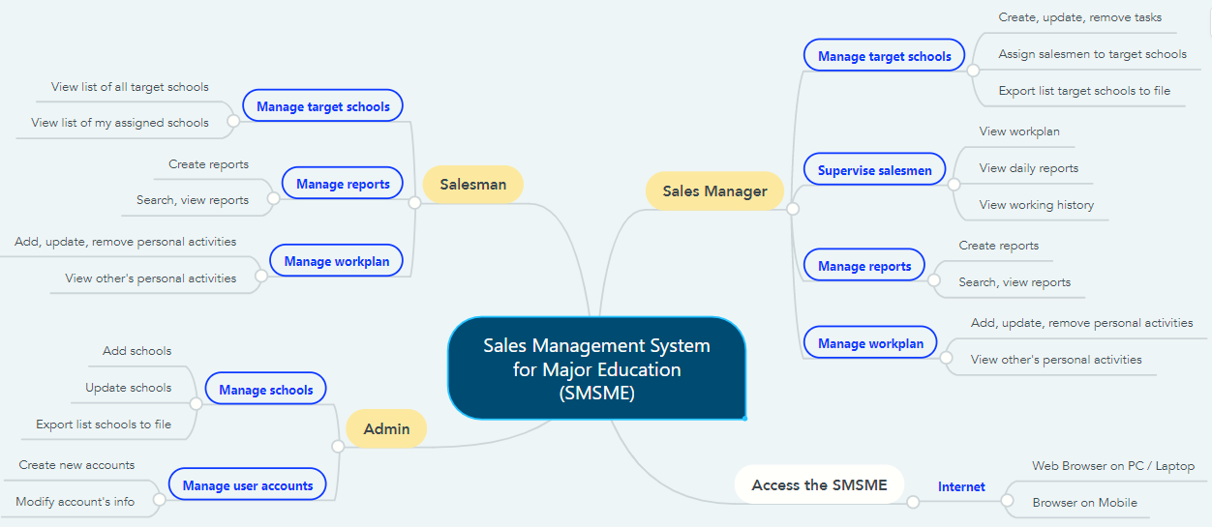

*Figure 1. Major Features*

### 6.2 Limitations & Exclusions

LI-1: The SMSME has not supported a Mobile application for role Salesman and Sales Manager. SMSME now is a responsive Web application.

LI-2: The SMSME does not relate to the content of contract between customers and Major.

LI-3: The SMSME does not support communication channel with customers.